**Exercise 1 – Application Identification**

**Name:** Badri MSV **Roll No:** 195002017

**Subject:** UIT1611 – Web Programming Lab **Faculty:** Dr. S. Sasirekha

**Date:** 15.03.2022

**Aim:**

Identify an application to design, build and deploy it as a composite web application.

**1. Introduction**

**1.1. Purpose**

The purpose of this document is to describe the following of the Time Table Reminder System:

* Features
* Scope
* Functional Requirements
* Constraints / Non-Functional Requirements

This document is intended for evaluation by the Web Programming Lab Faculty of SSN College of Engineering, and will be proposed to the same for approval.

**1.2. Scope**

The application will be a Time Table Reminder System intended to be used by both students and faculty alike. The application will be designed to take in the input of a Time Table either through HTML Forms or a .csv file. The user will be displayed what period they have to be in right now, along with the current time and date.

Extra information like classroom/lecture hall/meeting link can be added to the Time Table, and the user will have the option to opt in for getting notified of their current period via email. User can also choose to set manual reminders for any kind of task they like.

**1.3 Objectives**

The objective of this project/application are the following:

* To create a working web application
* To provide a simple Time Table functionality
* To allow users to set manual reminders
* To make following the schedule a bit easier for Students and Teachers alike
* To allow teachers to post any schedule changes for students to follow

**2. Functional Requirements**

**2.1 Login**

* User can login to their personal accounts
* Time Table and Reminders will be saved and displayed as per the account

**2.2 Time Table**

* The Time Table will be displayed to user in a simple, understandable format.
* Time Table itself can be entered manually by forms or by .csv file.
* Time Table will have options to add hyperlinks wherever the user requires.
* Time Table can be edited in the future if needed.
* User can opt for notifications to inform what classes are happening.

**2.3 Reminders**

* Users can manually set reminders.
* Reminders can have user defined title, date and time.
* User can opt for getting notified via email for each reminder.

3. Software Requirements

**4. Use Case Diagram**

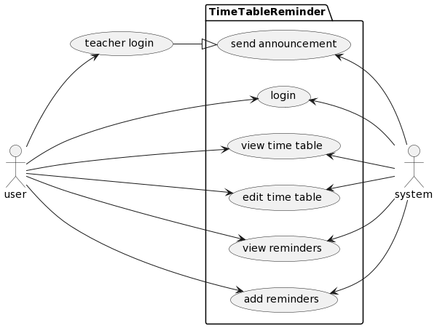

The main actors here are the user and the system.

The user interacts with all of the use cases: login, view time table, edit time table, view reminders and add reminders, except for the case where the user is considered a teacher. When a teacher logs in, they have an extra option of sending announcements.

The system interacts with all use cases as it has to store/retrieve data for each case.

@startuml

left to right direction

actor user

actor system

package TimeTableReminder{

usecase "login" as UC1

usecase "view time table" as UC2

usecase "edit time table" as UC3

usecase "view reminders" as UC4

usecase "add reminders" as UC5

usecase "send announcement" as UC6

}

user --> UC1

user --> UC2

user --> UC3

user --> UC4

user --> UC5

user --> (teacher login)

(teacher login) --|> UC6

UC1 <-- system

UC2 <-- system

UC3 <-- system

UC4 <-- system

UC5 <-- system

UC6 <-- system

@enduml

**Result:**

Thus, the requirements of the application was identified and documented.